

NCICB


caCORE SDK
Exception Handling Detail Design

Version No: 1.0
Last Modified: 07/13/2006

Author: Daniel Dumitru
Team: caCORE SDK
Client: National Cancer Institute - Center for Bioinformatics,
National Institutes of Health,
US Department of Health and Human Services

This document was prepared NCI Center for Bioinformatics
Pursuant to the caCORE Software Development Kit (SDK)
Project (REF: Solicitation No. S06-234).

Document History

Document Location
The most current version of this document is located in CVS under cacoresdk/Project/SDK v3.2/Development/Design.

Revision History
Version Number | Revision Date | Author | Summary of Changes
1.0 | 07/11/06 | Daniel Dumitru | Initial Draft
1.1 | 07/14/06 | Satish Patel | Formatting, grammar change

Review
Name | Team/Role | Version | Date Reviewed | Reviewer Comments

Related Documents
More information can be found in the following related documents:

Document Name

Table of Contents
Document History 2
0.1 Document Location 2
0.2 Revision History 2
0.3 Review 2
0.4 Related Documents 2
Table of Contents 3
Table of Figures 4
1. Introduction 5
1.1 Purpose 5
1.2 Intended Audience 5
1.3 Scope 5
1.4 Overview 5
1.5 Definitions, Acronyms, and Abbreviations 5
2. Exception Handling Detail Design 6
2.1 Problem Scenario 6
2.1.1 Analysis of Current caCORE SDK Exception Class Definitions and Usage 6
2.1.2 Problems with the ApplicationException Class 7
2.2 Proposed Exception Handling Enhancements 9
2.2.1 Introduction of More Specific Exception Classes 9
2.2.2 Code Changes to Classes that Use (Throw) ApplicationException 10
3. Configuration/Deployment Considerations 12
Property/Configuration Files 12
3.1 12
3.2 Deployment Considerations 12
4. Resources 13
4.1 Technical Manuals/Articles 13

;lk

Table of Figures

Figure 1: Current Set of caCORE SDK Exception Classes 6
Figure 2: An Example: The Use of Class DAOException 7
Figure 3: Packages that Use ApplicationException 8
Figure 4: Classes that Use (Throw) ApplicationException 9
Figure 5: Proposed Exception Class Hierarchy 10
Figure 6: Current Exception Handling Practice 10
Figure 7: Proposed Exception Handling Practice 10

Introduction

Purpose
The purpose of this document is to describe the current Exception handling practices within the generated system of the caCORE SDK, and to propose enhancements that more effectively communicate the cause of checked exceptions, while doing so in a manner that remains backwards compatible with the current release.

Intended Audience
The intended audience for this document includes Developers, Project Administrators, and End Users interested in the obtaining an overview of current and proposed enhancements to the exception handling practices within the caCORE SDK generated system.

Scope
The scope of this document is limited to a discussion of the current exception handling practices within the caCORE SDK generated system, along with proposed enhancements for improved usability. A discussion related to exception handling practices within the Code Generation portion of the caCORE SDK is beyond the scope of this document.

Additionally, an analysis of exception handling practices within the Web services portion of the generated system has been postponed due to time constraints, and will be addressed during a later iteration.

Overview
The following sections first provide a brief overview of the current Exception handling practices with the caCORE SDK generated system, following by recommended changes in order to enhance the usability and improve the communication of exceptional conditions to the system itself, to developers, and to end users. Finally, this document concludes with a section on configuration and deployment considerations.

Definitions, Acronyms, and Abbreviations
All definitions, acronyms, and abbreviations are provided in the centralized definition document found at cacoresdk/Project/SDK v3.2/Miscellaneous/Acronyms.doc.

Exception Handling Detail Design

Problem Scenario
This section describes the current Exception handling practices within the generated system of the caCORE SDK along with details as to why enhancements are desired.

Analysis of Current caCORE SDK Exception Class Definitions and Usage
A high-level analysis of the current caCORE SDK example code base shows that there is a relatively well-defined, specific set of Exception type classes, as shown below:

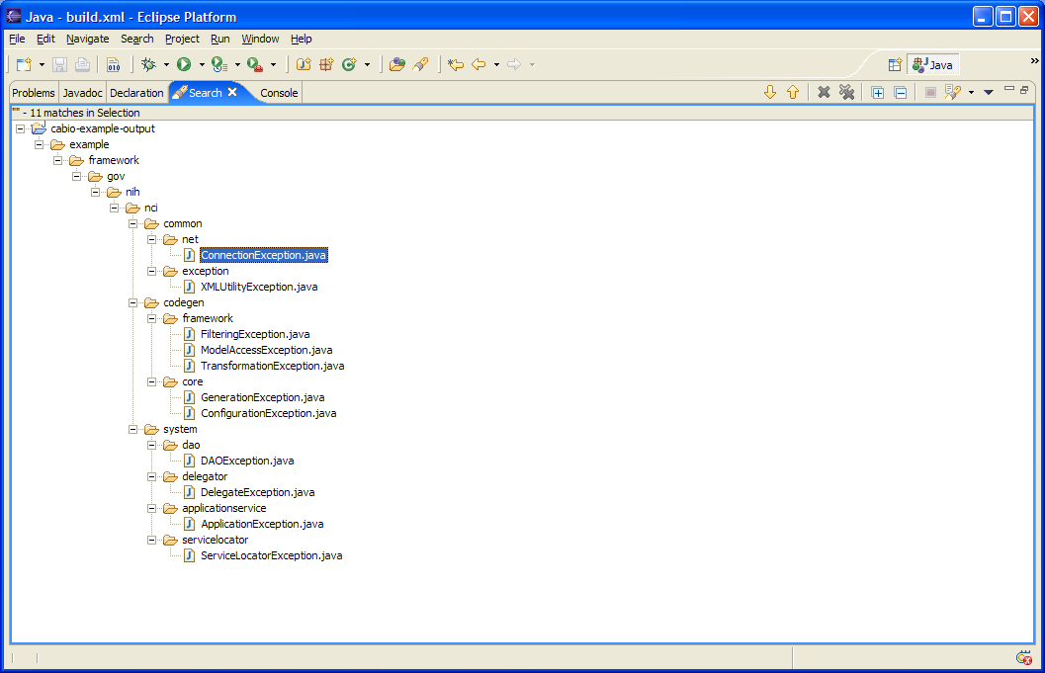
Relatively Well-Defined Set of Custom Exceptions Classes.
Scope of Exception Handling Focus within this Document
Analysis of Exception Handling Practices within the CABIO Sample System

Figure 1: Current Set of caCORE SDK Exception Classes

A closer inspection of the exception handling practices within the example generated system shows that, for the most part, exceptions are defined and used in a manner consistent with exception handling Best Practices: the exception name (type) communicates the kind of exception, the stack trace communicates the location to the SDK developer or programmer, and the exception message communicates additional information to the end user that might be helpful in determining and correcting the error.

As an example, let’s examine the usage of the DAOException class, shown below:

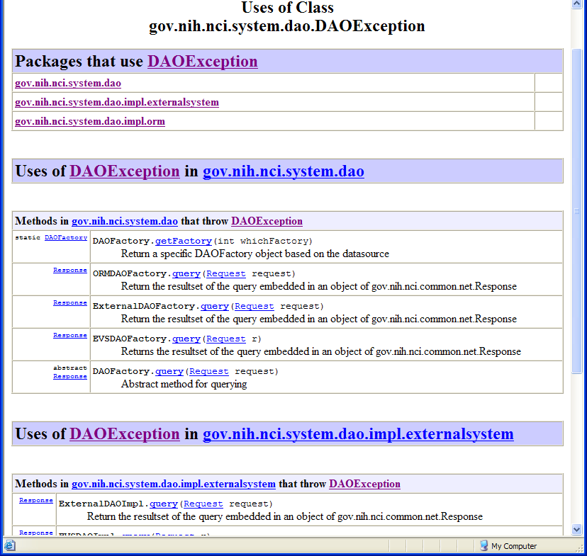
Relatively Well-Defined Set of Custom ExceptionsThe DAOException is both Defined and Used within the dao Packages and their Classes.
Relatively Well-Defined Set of Custom ExceptionsThe Methods that Throw DAOException are related to Data Access Functions..
Figure 2: An Example: The Use of Class DAOException

The DAOException class is both defined and applied within the dao packages and their classes. The use of the DAOException is also consistent with its type and definition; i.e., the methods that throw DAOException (e.g., get[DAO]Factory and query) are related in one form or another to data access functions. The developer, calling system, or end user that receives a DAOException thus has a pretty good idea as to the nature of the exception, its location, and the root cause of the problem.

However, as we will examine in the next section, this is not the case with one of the Exception classes, ApplicationException that is defined and used within the caCORE SDK generated system.

Problems with the ApplicationException Class

At first glance, the ApplicationException seems to also be defined and used in an effective manner. Its name seems to accurately convey the exception type, and is also consistent with its placement within the applicationservice package, and association with the ApplicationService interface.

However, as we examine how the ApplicationException is applied with the generated system, we notice that it is used for handling a wide variety of exceptional conditions that include query/search, persistence, and security functions, as shown in the following diagrams below:

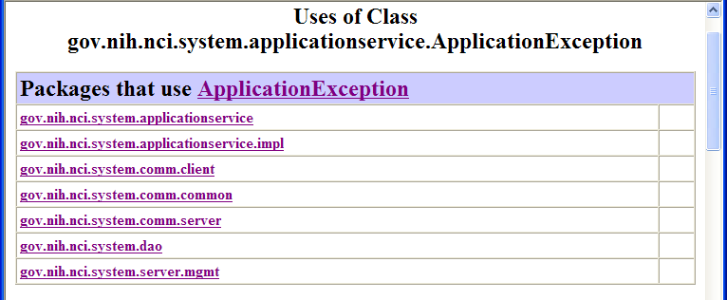
The ApplicationException is used generically within a Disparate Set of Packages and Classes that Implement Varying Query/Search, Persistence, and Security Functions.
Figure 3: Packages that Use ApplicationException

The listing and diagram below detail the variety of disparate classes, contained within the above package listing, that are associated with (i.e., that throw) ApplicationException:

- SecurityEnabler
- WriteableDAO
- Client Session
- ApplicationService
- ApplicationServiceClientImpl
- ApplicationServiceServerImpl

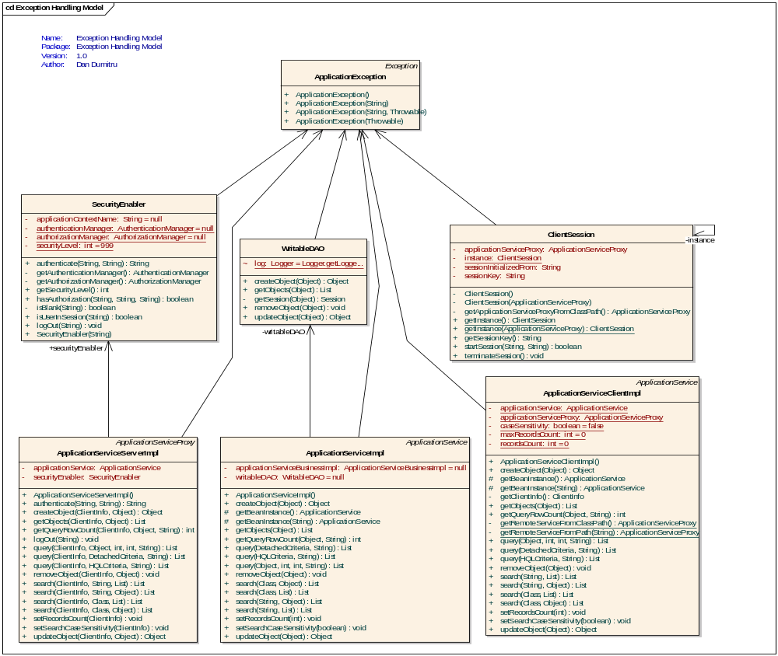
The ApplicationException is associated with (thrown from) a variety of classes, including:
- SecurityEnabler
- WriteableDAO
- ClientSession
- ApplicationService
- ApplicationServiceClientImpl
- ApplicationServiceServerImpl
Figure 4: Classes that Use (Throw) ApplicationException

Within this context, the ApplicationException name (type) becomes too general, and its usage too broad, to effectively communicate the root cause of the exceptional condition; end users are required to spend more time and effort than necessary interpreting and investigating the exception in order to determine the nature of the exception, its location, and the root cause of the problem.

Proposed Exception Handling Enhancements
This section describes the proposed exception handling enhancements that will more effectively communicate the cause of checked exceptions, and do so in a manner that remains backwards compatible with the current release.

Introduction of More Specific Exception Classes
In order to enhance the exception handling of the caCORE SDK generated system in a manner that preserves backwards compatibility with the current release, it is proposed that a more specific exception class hierarchy be created, as shown below:
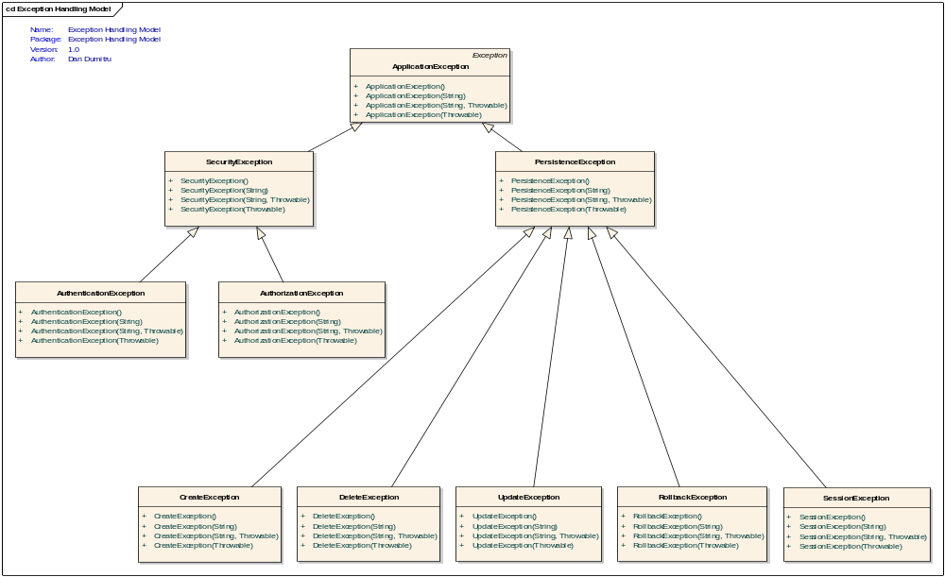
Figure 5: Proposed Exception Class Hierarchy
For improved readability, the same exception class hierarchy is provided below in list format:
- gov.nih.nci.system.applicationservice.ApplicationException
  - gov.nih.nci.system.applicationservice.SecurityException
    - gov.nih.nci.system.applicationservice.AuthenticationException
    - gov.nih.nci.system.applicationservice.AuthorizationException
  - gov.nih.nci.system.applicationservice.PersistenceException
    - gov.nih.nci.system.applicationservice.CreateException
    - gov.nih.nci.system.applicationservice.DeleteException
    - gov.nih.nci.system.applicationservice.UpdateException
    - gov.nih.nci.system.applicationservice.RollbackException
    - gov.nih.nci.system.applicationservice.SessionException

Alternate or additional persistence related exception classes under consideration (inspired by the javax.PersistenceException API) include:
- gov.nih.nci.system.applicationservice.EntityExistsException
- gov.nih.nci.system.applicationservice.EntityNotFoundException
- gov.nih.nci.system.applicationservice.NonUniqueResultException
- gov.nih.nci.system.applicationservice.NoResultException
- gov.nih.nci.system.applicationservice.OptimisticLockException
- gov.nih.nci.system.applicationservice.TransactionRequiredException
Sub-classing the proposed exceptions from a common parent, ApplicationException, allows exception handling to proceed in a more object-oriented manner. Callers that invoke the ApplicationService interface(s) can choose to treat all Application Exceptions equally as they do now with a single catch block. However, if callers desire to deal with one of the proposed Exception classes in a specific manner, then can catch the more specific exception type first and recover appropriately.

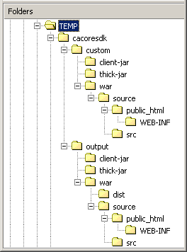

Code Changes to Classes that Use (Throw) ApplicationException
Classes that currently use (throw) ApplicationException will be modified to now throw one of the three (3) more specific exception classes, QueryException, PersistenceException, or SecurityException, as illustrated below:

catch (Exception ex)
{
throw new ApplicationException("Could not obtain session for this entity! Could not create object");
}
Figure 6: Current Exception Handling Practice

catch (Exception ex)
{
throw (ApplicationException)(new SessionException("Could not obtain session for this entity! Could not create object", ex));
}
Figure 7: Proposed Exception Handling Practice

With this practice, none of the existing method signatures would change, thus preserving backwards compatibility with the current release.

Additionally, the proposed exception handling practice now also preserves the original exception via the constructor that takes a throwable cause as the second argument, thus providing more detailed information to the caller catching the thrown exception.

Configuration/Deployment Considerations

Property/Configuration Files

New (*) or Modified (#) | File Location | File Name | Description of Change
# | gov.nih.nci.system.dao | WriteableDAO.java | Modify class to throw PesistenceException cast as an ApplicationException.
# | gov.nih.nci.system.comm.server | ApplicationServiceServerImpl | Modify class to throw sub classed exceptions of ApplicationException.
# | gov.nih.nci.system.comm.client | ApplicationServiceClientImpl | Modify class to throw sub classed exceptions of ApplicationException.
# | gov.nih.nci.system.comm.client | ClientSession | Modify class to throw sub classed exceptions of ApplicationException.
# | gov.nih.nci.system.applicationservice.impl | ApplicationServiceImpl | Modify class to throw sub classed exceptions of ApplicationException.
# | gov.nih.nci.system.server.mgmt | SecurityEnabler | Modify class to throw sub classed exceptions of ApplicationException.
* | gov.nih.nci.system.applicationservice | SecurityException | New Subclass of ApplicationException
* | gov.nih.nci.system.applicationservice | AuthenticationException | New Subclass of SecurityException
* | gov.nih.nci.system.applicationservice | AuthorizationException | New Subclass of SecurityException
* | gov.nih.nci.system.applicationservice | PersistenceException | New Subclass of SecurityException

Deployment Considerations
N/A.

Resources
This section contains a list of recommended reading materials, resources, and references that can be useful for becoming familiar with the exception handling concepts contained within this guide.

Technical Manuals/Articles
- Exceptional Practices: http://java.sun.com/developer/technicalArticles/Programming/exceptions/.
- Exceptional Practices, Part 2: http://java.sun.com/developer/technicalArticles/Programming/exceptions2/.
- javax.persistence class hierarchy: http://java.sun.com/javaee/5/docs/api/javax/persistence/package-tree.html.
- See also the java.lang.Throwable API regarding the Exception Chaining facility.

The cabio example system provided with the caCORE SDK is used in our discussion for the sake of simplicity. However, the ideas discussed in this document apply to any caCORE-like system generated via the SDK.
See the Resource section at the end of this document for a list of references to Exception Handling related articles.
See http://java.sun.com/javaee/5/docs/api/javax/persistence/package-tree.html.
As noted in the java.lang.Throwable API, this feature is also known as the chained exception facility, as the cause can, itself, have a cause, and so on, leading to a "chain" of exceptions, each caused by another. One reason that a throwable may have a cause is that the class that throws it is built atop a lower layered abstraction, and an operation on the upper layer fails due to a failure in the lower layer. It would be bad design to let the throwable thrown by the lower layer propagate outward, as it is generally unrelated to the abstraction provided by the upper layer. Further, doing so would tie the API of the upper layer to the details of its implementation, assuming the lower layer's exception was a checked exception. Throwing a "wrapped exception" (i.e., an exception containing a cause) allows the upper layer to communicate the details of the failure to its caller without incurring either of these shortcomings. It preserves the flexibility to change the implementation of the upper layer without changing its API (in particular, the set of exceptions thrown by its methods). A second reason that a throwable may have a cause is that the method that throws it must conform to a general-purpose interface that does not permit the method to throw the cause directly. For example, suppose a persistent collection conforms to the Collection interface, and that its persistence is implemented atop java.io. Suppose the internals of the put method can throw an IOException. The implementation can communicate the details of the IOException to its caller while conforming to the Collection interface by wrapping the IOException in an appropriate unchecked exception. (The specification for the persistent collection should indicate that it is capable of throwing such exceptions.)

